**Deliverable # 1**

*Prioritized User Requirements*

SEG 3101 - Section B00

Dr. Andrew Forward

Laboratory A01

Group 19:

| **Linna She** | **300006289** |
| --- | --- |
| **Yuemeng Wu** | **300035107** |
| **Zihan Xiao** | **300048507** |
| **Haotong Ge** | **300073862** |
| **Wei Liu** | **300005620** |
| **Kaiwen Song** | **300028982** |

**Submission Date: Saturday, October 8th, 2021**

### **Table of Contents**

### 

### 

| **Introduction** |  | **3** |
| --- | --- | --- |
| **User Requirements** |  | **3** |
| **Discussion** |  | **6** |
| **References** |  | **8** |

### 

### 

### 

### 

### 

### 

### 

### 

### 

### **Introduction**

Products are now developed based on what customers desire, and thus attractive quality creation has become crucial. The focus of this study is on the prioritization of customer requirements (CRs) in software development.

The product is a payment system of a gym named “MeFit”. We analysed the requirements of our customer and listed all of their requirements and ranked all of them by their priority in this document below.

In this project, we mainly focus on analysis software requirements and we will gain more practical experience through this project. We mostly implement our work using Helix ALM and Our Helix ALM ink is attached below:

Helix ALM link: <https://uottawa.helixalm.cloud/ttweb/#default/120/home?dashboard=1>

### **User Requirements**

| **No.** | **User Requirement** | **Priority（rank）** |
| --- | --- | --- |
| **1** | **The system shall allow licensees to view available products for sale within 2 selected dates** | **Basic (highest priority)** |
| **2** | **The system shall allow users to purchase fitness equipment.** | **Basic (highest priority)** |
| **3** | **The system shall allow users to cancel their subscriptions at any time.** | **Basic (highest priority)** |
| **4** | **The system shall allow users to sign up for courses offered by Mefit.** | **Basic (highest priority)** |
| **5** | **The system shall support trainers to certify their professional licenses and display user types in the community** | **Basic (highest priority)** |
| **6** | **The system shall allow the users to participate in the virtual competition.** | **Basic (highest priority)** |
| **7** | **The system shall allow third parties to post fitness events.** | **Basic (highest priority)** |
| **8** | **The system shall allow gyms to provide professional training for trainers** | **Basic (highest priority)** |
| **9** | **The system shall allow licensees to adjust their own price.** | **Basic(highest priority)** |
| **10** | **The system shall allow secure access to users' information for third party sanctioned institutions.** | **Basic (highest priority)** |
| **11** | **The system shall prevent affiliates, trainers and customers information from being accessed by unauthorized users.** | **Basic (highest priority)** |
| **12** | **The system shall invite users to participate in the Mefit yearly fitness competition.** | **Satisfier (high priority)** |
| **13** | **The system shall adjust the schedule time according to the time zone of the user's device** | **Satisfier (high priority)** |
| **14** | **The system shall allow purchasing customers to choose their payment method from a predefined list.** | **Satisfier (high priority)** |
| **15** | **The system shall support the display of different national languages in the system language.** | **Satisfier (high priority)** |
| **16** | **This system shall enable users to see the usage of their plan.** | **Satisfier (high priority)** |
| **17** | **The system shall allow the users to create discussion forums in the community** | **Satisfier (high priority)** |
| **18** | **The system shall allow users to reply to existing communication posts.** | **Satisfier (high priority)** |
| **19** | **The system shall allow different users to make payments with different currencies based on predefined currencies.** | **Satisfier (high priority)** |
| **20** | **The system shall allow users to edit a fitness plan.** | **Satisfier (high priority)** |
| **21** | **The system shall allow gyms to provide the private customized courses for members.** | **Satisfier (high priority)** |
| **22** | **The system shall provide customer relationship management service through SF.** | **Satisfier (high priority)** |
| **23** | **The system shall allow licensee gyms adjust their own teaching methods according to the customer needs.** | **Satisfier (high priority)** |
| **24** | **The system shall allow users to register for competition.** | **Satisfier (high priority)** |
| **25** | **The system shall allow users through at most 3 steps to make payments.** | **Satisfier (high priority)** |
| **26** | **The system shall provide online courses so that customers can exercise at home.** | **Satisfier (high priority)** |
| **27** | **The system shall allow users to use promotion code to get a discount.** | **Delighter (normal priority)** |
| **28** | **The system shall allow trainers to have a membership price for purchasing equipment.** | **Delighter (normal priority)** |
| **29** | **The system shall allow users to choose the plan that best suits them.** | **Delighter (normal priority)** |
| **30** | **The system shall provide customers with a reasonable and healthy time schedule.** | **Delighter (normal priority)** |
| **31** | **The system shall recommend different fitness meals to different groups of people.** | **Delighter (normal priority)** |
| **32** | **The system shall allow admin to edit a training group.** | **Indifference (low priority)** |
| **33** | **The system shall allow users to simulate the consumption of a specific set of sports.** | **Indifference (low priority)** |

### **Discussion**

In this study, it was aimed to classify the consumer expectations by using the KANO model(Figure.1) in new product development and to determine the extent to which products produced in the desired direction provide satisfaction. To some extent, this can also be used to prioritize user requirements planning in software development.In fact, the KANO model has a very fine and professional algorithm, our project only refers to the classification of the KANO model.

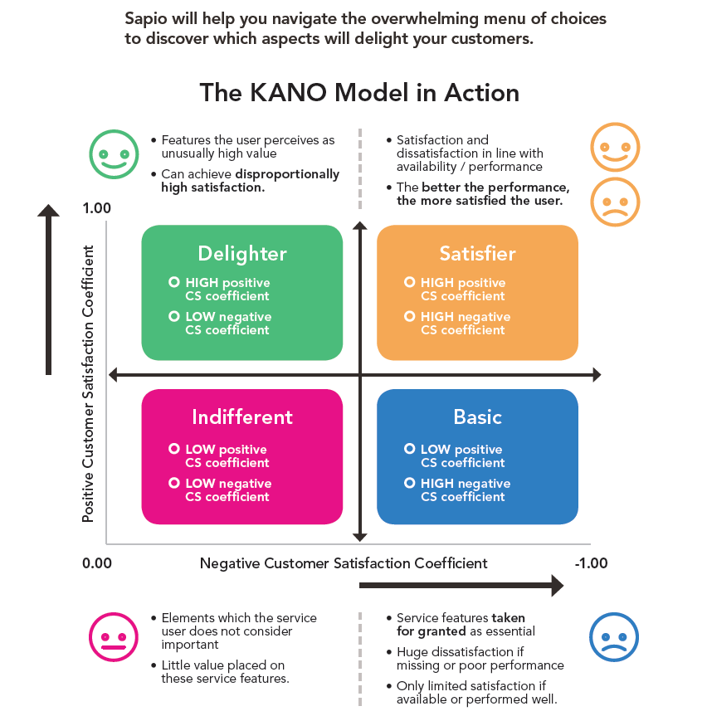

Figure 1: The KANO Model in Action

Kano’s method is a good way to investigate the characteristics of customer requirements. By using Kano’s method one can clarify the difficult-to-see customer requirements by classifying them into a few groups and by locating each requirement on a graph.In the same way, we will use four different colors to identify the priority of the user's needs. Blue (Basic) is the highest priority, a level that means the user cannot experience the most basic functionality in the system. This can also be founded from the pain points of the business, MeFit, for example, they mention that users from other countries cannot use PayPal in the system or cannot pay in their own currency. In this case, 'Adding PayPal payment channel' should be considered a blue priority. The yellow color (satisfier) is based on the basic functionality of the user who wants to add more convenient features, which does not have to be implemented immediately.Delighter uses green in the KANO model to indicate this part of the requirement. It can be UI related or otherwise, satisfying this part of the requirement can increase software’ user loyalty and dependency.Finally, the red indifferent is a completely useless requirement for improving the user experience.This can be interpreted as an impractical and unwelcome demand, such as ‘The Uber application shall allow user buying Bus pass’, which is not practical for the group of users who use Uber.

Additionally, when we can't unify our opinions on priorities, we would discuss two questions: 1. How do you feel if you have this feature? (Functionality question) 2. How do you feel if you don't have this feature? (Dysfunctional question), the chart(Figure.2) shows how each feature is categorised based on the answers to the functional vs dysfunctional questions. According to this method, it help us quickly clear the irrelevant user requirements (I) and questionable user requirements (Q)

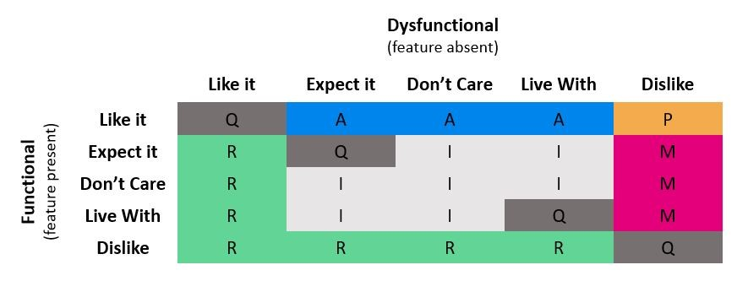

Figure 2: functional vs dysfunctional in KANO Model

**A** – Attractive features – These features are not expected but are liked by customers

**M** – Must-be features – These are must have features and customers dislike not having them

**P** – Performance features – Features customers like having and dislike not having

**I** – Indifferent features – Customers are neutral to the feature or can tolerate it

**Q** – Questionable features – Conflicting responses from customers

**R** – Reverse features – When customers like not having the feature or dislike having it

### **References**

1. Lee, Yu-Cheng, Liang-Chyau Sheu, and Yuan-Gan Tsou. "Quality function deployment implementation based on Fuzzy Kano model: An application in PLM system." *Computers & Industrial Engineering* 55.1 (2008): 48-63.
2. Shen, Xiao-Xiang, Kay C. Tan, and Mien Xie. "An integrated approach to innovative product development using Kano’s model and QFD." *European journal of innovation management* (2000).
3. ​​Figure 1&2 Retrieved from：<https://sapioresearch.com/kano-analysis>